Lab 6
In Lab Submission Tasks:
Example 1: Simple TCP Chat Application
Chat Server:
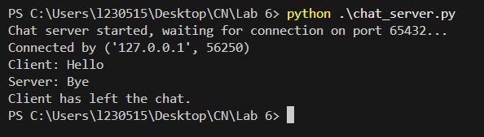
Chat Client:
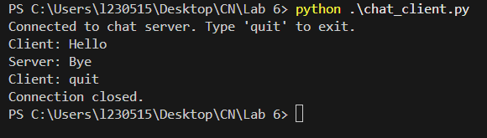

Example 2: Simple TCP File Transfer
File Server:
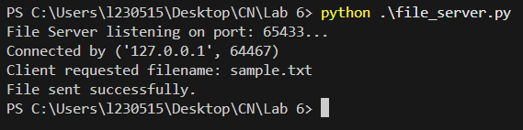

File Client:
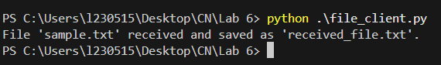

Example 3: TCP Echo
TCP Echo server:
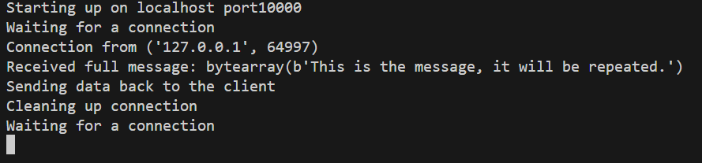
TCP Echo client:
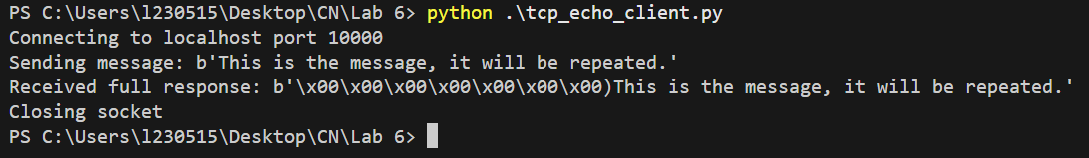

Task 1:
Server:
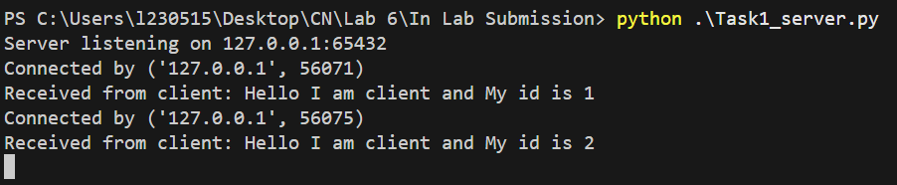
Client:
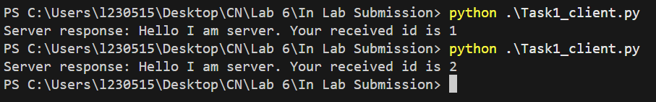
Home Submission Tasks:
Task 2:
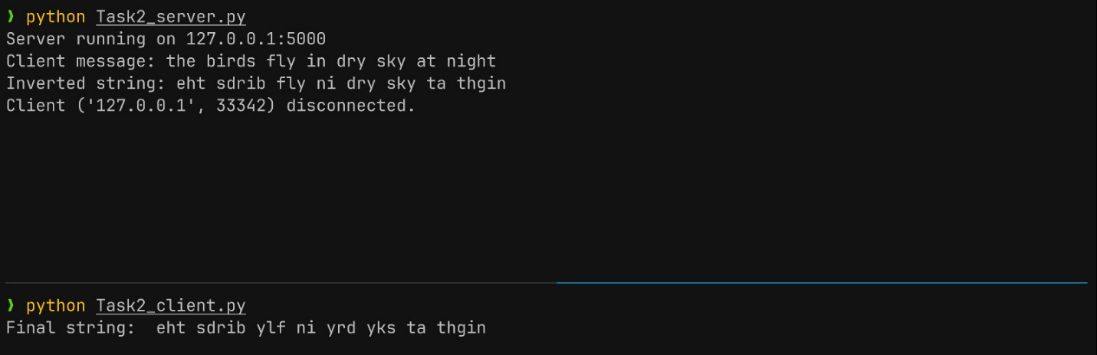

Task 3:
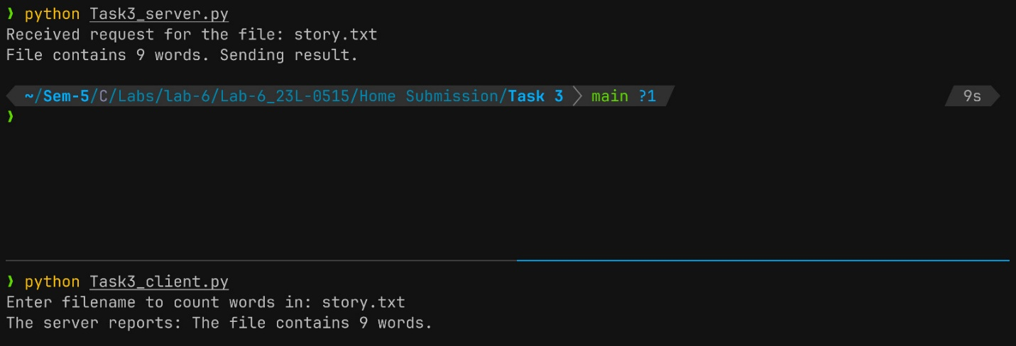

Task 4:
